ELECTRICAL APPLIANCE SAFETY CERTIFICATE

PORTABLE APPLIANCE TESTING
This is to certify that
CHANCE2DANCE MOBILE DISCO’S
of
32 ADMIRALTY STREET
STONEHOUSE
PLYMOUTH
PL1 3RX

Has been tested for

ELECTRICAL APPLIANCE SAFETY
For one year

Inspection date 11th Feb 2025
Next test due 10th Feb 2026
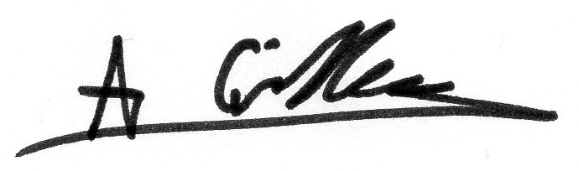

Signed

For details of items inspected, please consult our “Portable Appliance Testing Record Sheet” of the same date.

